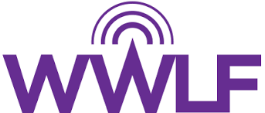

The Women’s Wireless Leadership Forum
2023 Mentee Application

MEMBER INFORMATION:

First Name:

Email Address: Phone Number:

Company: Title:

MENTEE QUESTIONAIRE:

- How long have you worked in the wireless industry?

- What are your primary goals for this mentoring relationship?

- What are three goals you are working towards this year?

- What professional areas would you like to grow this year?

- What is one thing you like to do in your personal life?

- What days/times work best for your mentoring sessions? (To Be Held Every Month)

- If you would like, please share any additional information, which may be beneficial in the pairing process.

Please return this form along with your resume to Kelsey Trundle at Programs@wwlf.org.

